Week 5 Reading and Assignments
Complete the following reading early in the week:
- Week 5 online lectures
- From your textbook, Exploring Digital Cinematography, read the following chapters:
  - Traditional Lighting Techniques (review)
  - Virtual Lighting
  - Wrapping It Up—Materials and Textures
- Review the text 3ds Max 2010 Bible as needed to reinforce and expand on the concepts and techniques required for this week’s assignments.
- Visit the following Web links:
  - CG Architect: Advanced Lighting Techniques
  - CG Architect: Lighting and Shadow Basics - Part 1
  - CG Architect: Lighting and Shadow Basics - Part 2
  - CG Architect: Lighting and Shadow Basics - Part 3
  - Video Expert: Lighting in a Nutshell
  - Game Dev: Shadows
  - NewTek: LightWave Rendition
  - Brian Lemay: Animation Tips
  - Brian Lemay: Animation Tips & Tricks
Assignment Summary: Week 5 | Due Date
Assignment 1: Discussion Questions | Friday, June 11, 2010
Assignment 2: Changing the Depth and Focus | Sunday, June 13, 2010
Assignment 3: Final Project—Final Render | Tuesday, June 15, 2010

Week 5 Overview
What is it about light that intrigues humans?
Human beings have always associated light with comfort, security, and survival. Light and luminescence represent holy imagery and, in some cultures, light is the embodiment of deities!
Today, light is a separate field of study for physicists. People have devoted their entire lives to understanding how it propagates in space, looks in different circumstances, and affects the world around us. Light is defined by mathematical formulae and can be measured with sensitive scientific instruments. Yet, in its fluid and changing nature, light is something that is still elusive. Over the centuries, humans developed and manipulated it in many ways and, today, you even find it existing as an art form. So, light seems to have grown from being a mere source of warmth and security into something special and meaningful for humankind.
This week, you will look at the important role that light plays in shaping the intent and emotions in your scenes.

Learning Outcomes:
Know how to use the essential components of the software animation environment to create compelling imagery.
Light and How it Propels the Game Play
In previous weeks, you experimented with the basic three-point lighting for a scene. You are also familiar with the parameters of light such as intensity, color, and decay. Let us now discuss the features of light that can be used to bring out different effects in a scene.
Developers and directors often use light to focus on an object or a person in their works. In some cases, you can also observe the use of light to set a mood by overarching colors in a scene. Light has always played an important role in the creation of visually compelling scenes. For games, it also helps guide the player from one area of the environment to another. However, like good and meaningful camera movements, good scene lighting should never draw attention to itself. You can always achieve a natural and subtle lighting in a scene by placing lights according to the story intent. If cleverly used, you can make light look seamless and unnoticeable to a casual viewer. Lights need careful treatment, and a good director avoids placing lights in a scene simply to make people see things better.
Let's recall the role-playing shooter, BioShock. In this game, the developers have used light and color to convey the story of the game and enhance the game play. You can better understand the logic behind the use of lights and colors schemes in the game by understanding the story line of the game. In the story of BioShock, the characters exist in a World War II era underwater world called Rapture. The main character, Jack, is a passenger on a plane that goes down in the Atlantic Ocean in 1960. At this point in time, Rapture’s ordered society has already fallen apart. Originally founded by Andrew Ryan in 1946, Rapture was a city of progress and science. As Jack progresses through the story world, he begins to piece together what Rapture was, how it came to ruin, and what Jack’s relationship to Ryan really is. The player is guided through the many different buildings and areas of Rapture with a radio and a guide named Atlas, who once inhabited Rapture with his wife and child. Rapture is now overrun with monsters called Splicers, genetically enhanced humans, who literally slice their way through people.
The developers depicted this underwater world with a unique color scheme and lighting logic that is also reflexive of the World War II era it was built in.

Let's discuss some examples from this game in which the developer's judicious use of lights played an important role in propelling the story.
In the opening scenes of the game, Jack is on a plane, looking through the pictures in his wallet, talking about the great things he was meant to do in his life. The scene is darkly lit, with a spot light on the wallet, reflecting the reading lamps found in airplanes. This also helps to draw the player’s attention to the object Jack is holding instead of looking around at the rest of the environment. This same light is also used as Jack picks up a gift wrapped box that has a tag on it. Because of the placement of this light, we can clearly read who the gift is from, learn what our character’s name is and start to piece together the story about to unfold.
In a larger story context, the color and light setup in the opening sequence brings a sense of curiosity to where Jack is heading, and what is about to take place. As the plane crashes, we get more clues as water begins to flood the frame.
Much of the game world is dark and damp. The lack of light in the overall scene design leads the player to believe that danger lies around every corner. Many of the objects within the game world provide what little light there is. For example, many of the rooms Jack enters have neon florescent signs. The signs give off not just light, but colored light. So when Jack enters a room with a red neon sign the whole environment has a red tint to it. This is very helpful to the player as it allows them to separate out different areas of the world depending on the signs used.
The developer has frequently used classic film noir lighting in the game. Film noir is a French term that means black film. The darkness and the harsh contrasts of the frames add to the feeling of mystery and secrecy.
Once the plane has crashed and Jack manages to swim to the surface, there are pieces of fuselage on fire all around Jack. As the player, you have to safely navigate him to a huge beacon that seems to miraculously be where the plane has crashed. If Jack begins to swim out to sea, the developer had placed other pieces of the plane that will ignite with large orange and red flames, forcing the player to go a different way. The closer the player get to the beacon, bright white lamps begin to light leading to an inner chamber and an elevator down to Rapture. In this sequence, the developer used light in two different ways to help the progress of the scene and story. First, we have the fire that will irrupt if the player maneuvers Jack too far out to sea. This helps keep the player on task with where they have to go as the game world can be confusing without cues to keep them on the right path. It also helps illuminate the beacon in front of Jack in a bluish golden hue. It helps emphasize the water adventure he’s about to partake in but it also leaves the player a little disconcerted as the shadows that fall on the beacon signal danger ahead. Second, we have the lights that lead up the stairs and to the elevator down to Rapture. In waiting until Jack gets close enough to the stairs to light them, the player is given another cue of “this is where I’m supposed to go.” This scene can also be viewed as a tutorial, because this use of lights will remain for the duration of the game. Once the player begins to understand that lights will lead the way, the movement through the game world will become easier.
The developers intentionally used lights to reflect the watery world in which the story takes place, but also to light the way for the player’s movement.
Lighting for a Story
For any developer, lighting a scene can be one of the most challenging aspects of creating convincing and realistic images for a story. While determining lighting setup for your scenes, it is important to understand that lights not only help your viewers to see the elements of the scene clearly, but also they have a profound effect on the mood and intent of each element of the story. With appropriate lighting, you can bring out or push back elements in your composition, define personality of your characters, or even manipulate the emotions of your viewers.
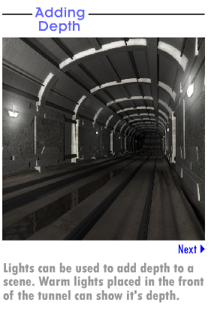
Colors add another dimension to the lighting of your scenes. Color and light are so interwoven that they are impossible to separate from each other. When light rays fall on an object, the object absorbs some parts of the spectrum and reflects other parts. The reflected part of the spectrum determines the color of the object. When the color of light on the object is white or when the light is lacking in color, the object is entirely perceived in its "local color." However, if you change the color of light on the object, your perception of the local color of the object also changes. For example, red lights force more of the reds in the spectrum to be reflected outward. Therefore, all the objects seen in red light look red. The same is true for the blue, green, and yellow lights.
Warm Colors
Warm colors are frequently used to evoke a sense of tension and excitement on the screen. However, many directors also use warm colors and bright illumination to make things pleasing and inviting to the viewer's eye. You can also use them to bring focus to the specific elements of your composition.
Cool Colors
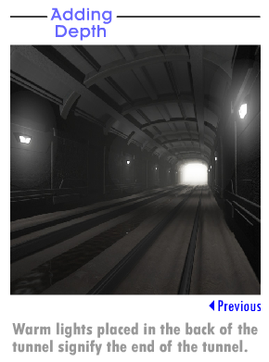
The cooler colors are typically used to depict the simpler scenes such as the usual workplace scene, scenes portraying the day-to-day routine life, or a common marketplace. These scenes are often illuminated with blue and green lights. These colors are difficult for the eye to settle on and are considered pleasing in their temperature and intensity.
Because we are dealing exclusively with the placement and arrangement of lights in visual story telling, let's now address how to maximize the use of lights in context of a scene. We will also explore how lights can be used to manipulate a scene's composition and the story's intent.
In the frame, colored lights can be used for a dual purpose. You can use these color scenarios to deal with the depth and focus of a scene. Each of these approaches is valid and efficient, but must be used judiciously and in accordance with the story goal and intent.
Adding Depth
With appropriate intensity and direction of light rays, you can show or hide the finer details and bring out the depth of an object. For instance, by placing the key lights at an appropriate angle to the camera, you can bring out the highlights and shadows of the objects in a scene. This directional use of key lights results in creating shadows and a graduated fall in light intensity from bright to dark that gives the illusion of depth in the image.
You can also use colored lights in a scene to add depth to an image. For instance, cooler colors, such blue and green, recede in a composition and add depth to the image. However, the warmer colors, such as red and yellow, are more volatile and evident in a composition.
By adding warm color lights to the foreground of the shot, a developer can bring warmer-lit elements forward in the composition. By keeping the colors in the midground and background cooler, compared to the foreground, you can create a much deeper image. Therefore, if the point of the scene is to show how deep a tunnel or hallway goes into the distance, then you can arrange light in a subtle way; so that the foreground is slightly warmer than the background. This effect does not have to be a heavy-handed. In many instances, you should leave the effect subtle to achieve a natural and believable scene. If you were to reverse the effect, and put cool lights in foreground and warm lights are in the background, you would see the end of tunnel in the scene.
Changing Focus
Besides adding depth and emotional intent to a scene, you can also use lights and colors to move the focus of the scene in a different direction. For example, by lighting foreground elements in dull lights you can effectively take the focus off them. You allow the eyes of the viewer to move more directly towards the focal point of an image if that focal point is brightly lit, compared to its surroundings.
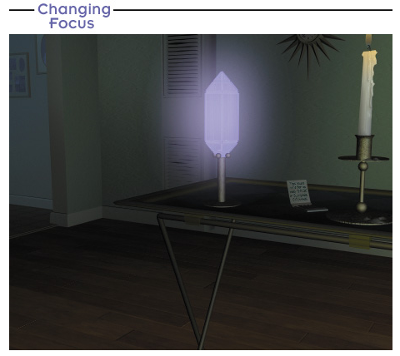
You can also draw attention of viewers to a subject by surrounding the subject with shadows. The dark shadowed area around the subject will also help you to bring out the sharp outlines of the object. For example, in a scene of a scared child in a dark hallway, you can use the dark shadows surround the child to effectively bring out the emotions on the child's face.

Changing the Emotional Response
In another scenario, if the intended story effect is to make the front porch of a house look as if it were a haven in a scary and a darkly lit neighborhood, you can make the lights of the front porch warm and soft, thereby bringing the viewer's focus to the porch. Now, visualize the same front porch of the house bathed in a cold blue light. The difference in lighting changes the entire story intent and the emotional reaction of the viewer. The cold blue light becomes an extension of the dangerous night.
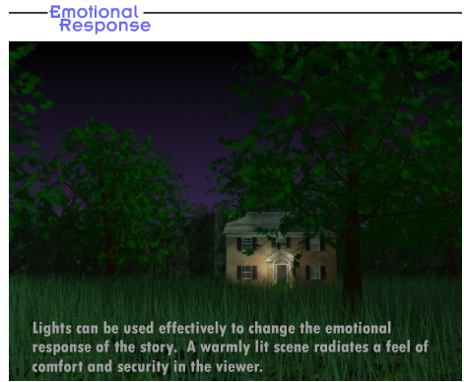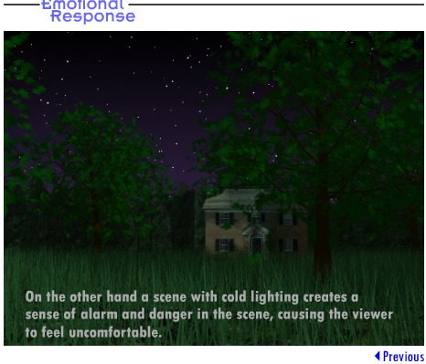

The lesson that you learned here is that, along with the placement and movement of camera, the placement of lights and colors can easily affect how you perceive space in real life and in CG. As a director, never take the placement of lights for granted or they can work against you!
Placing the Lights
Lighting can emphasize the important details of your scene or completely hide them. You can use lights to flatter a subject by bringing out positive attributes and, at the same time, you can also use it to de-emphasize or hide the less attractive attributes.
No master lighting scheme or setup can consistently create brilliant lighting scenarios. As a director, every shot will present you with a different challenge and problem. However, the most important aspect of lighting is the management of primary and secondary lights.
Primary Lights
We have discussed the basic three-point lighting in the Week 2 lectures. As you learned, the key light is the master light by which most changes of the lighting scheme are measured. The master light is the foundation or the primary light of the scene and often the sun in outdoor shots or the moon in night shots. In indoor shots, the most brightly lit lamp in a room or the fluorescent bulbs in the ceiling can be the master lights. If you do not manage key lighting properly, the shot will have too many variables to manage efficiently. The effect would be like a large office full of cubicles, but with only small lamps in all of the individual cubicles. Therefore, by efficient management of the primary lights, you can manage the foundation of scene lighting.
Secondary or Reflected Light
The other aspect of working with lights is managing the secondary or reflected lights. Light rays bounce back when they hit the surface of an object. Every surface in an environment is illuminated by a combination of direct light from the source of light and reflected light from the surface of the objects. In the CG world, this phenomenon is known as radiosity.
Click on this link below to know more about radiosity:
http://www.gamedev.net/reference/programming/features/rtradiosity/default.asp
Today, all high-end 3D software provides the standard feature of radiosity or a system of computer-calculated, bounced light. However, it needs immense computing power and time to make radiosity usable for a production. Because it requires such vast amounts of computer resources, radiosity is often considered a notorious power hog. Apart from the prohibitive computing costs, radiosity also sometimes makes scenes look less than aesthetically ideal. Therefore, it is important to understand how to set up an effective lighting scenario without using the radiosity function.
It is always good to know how to do things by hand as mastering these skills will always give you the comfort of knowing that you can handle your scenes in either situation with or without using radiosity. Radiosity, at its simplest level, is a way for a computer to decide on the placement of bounced light. A director who understands how reflected light works can effectively make that decision for himself or herself.

We've now discussed the two basic forms of light—primary lights and secondary lights—which make things visible to the viewer. All other lights are geared toward getting the specific effects and bringing attention to those parts of a frame for which the two principle lights are not providing appropriate coverage. These lights are placed according to the scene's requirements, and unless they are being used to bring attention to the focal point of a shot, their intensity shouldn't be too strong.
A developer who manages these basic principles and ensures that his or her decisions are guided by the story alone, should have no problems with the foundations of arranging lights in the scenes.
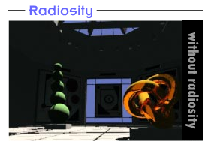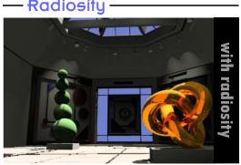
Effects and the Final Touches
After setting the lighting for the shot, your final step should be to create the effects and finalize the shot.
On a more global level, you can use fog or rain for the environmental effects. You can assign fog to any camera in the scene and use it in combination with rain to make some effects that add depth and life to a shot. It is important that you experiment with these techniques because they can become complicated in their results. Also, you need to make careful decisions with these techniques because they may increase the rendering time of your scenes.
Finally, one last item that you can use to add depth in a shot is the lens. By turning on the multi-pass render effect in your camera, you can make your computer use the focal depth of your camera as the focal point of the image and blur all other elements around that focal point. By turning on this function, you are essentially directing the software to render the image several times to achieve this effect. This effect also requires a considerable amount of your computer's memory and increases the rendering time; therefore, use it judiciously in the scenes where story demands it.

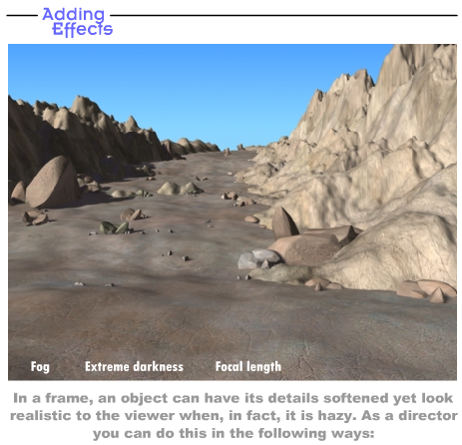
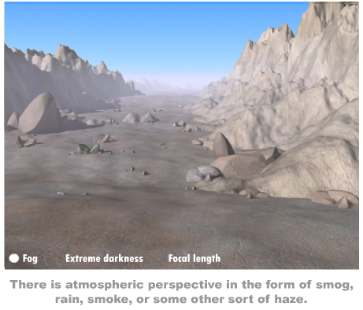
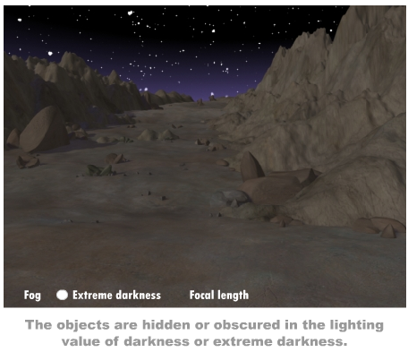
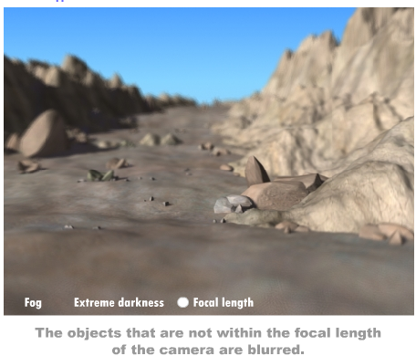

Summary
We have now discussed how light and color change the perspective of the scene. You learned about some light and color features that help bring out the intent and emotions in your scenes. All the high-end 3D software today offer these and many more features to create the lighting effects in your scenes. Experiment with them and see what they can do to add value to your shot. If they don't add any value to your scenes, take them out. Remember that all the effects that you add increase the use of your computer's resources and might only slow down the rendering process.
Assignment 1: Discussion Questions
By Friday, June 11, 2010, go to the Discussion Area and post responses to two of the discussion questions assigned by the facilitator. All responses should be posted to this Discussion Area.
Before the end of the week, begin commenting on at least two of your peers' responses. You can ask technical questions or respond generally to the overall experience. Be objective, clear, and concise. Always use constructive language, even in criticism, to work toward the goal of positive progress. Submit your responses to the appropriate topic in this Discussion Area.
Assignment 1 Grading Criteria | Maximum Points
Response Criteria
Met the criteria for the correct responses to the questions assigned. | 4
Used vocabulary relevant to the current week's topics—at least four terms. | 4
Participation Criteria
Used vocabulary relevant to the current week's topics—at least four terms. | 4
Participated in the discussion by asking a question, providing a statement of clarification, providing a point of view with rationale, challenging a point of discussion, or making a relationship between one or more points of the discussion. | 4
Justified ideas and responses by using appropriate examples and references from texts, Web sites, and other references or personal experience. | 4
Total: | 20
For assistance with any problems you may have when completing this assignment—OR—to offer your assistance to classmates, please use theProblems and Solutions Discussion area located through the left side navigation link.

Discussion Question 1 : Scene Lighting
Think of a scene that you would like to create in future. It can be any scene from your daily life, a movie, or just your imagination. Give a brief description of this scene detailing the story element and emotional intent of this scene. How would you handle the lighting setup of this scene? How will you use the colored lights to bring out the intent of this scene? Be specific on the depth, focus, and emotional intent of the scene.

Discussion Question 2: Light and Camera in Environmental Conditions
Can you name a scene from a game in which environment and weather effects played a crucial part in the story? Would this game have been the same without the light and camera play to create these environmental conditions? How did the camera and lighting contribute to those environmental conditions in the story?

Discussion Question 3: Shadows
Shadows are the integral part of light. Discuss how shadows help to create realistic imagery. Enumerate the situations where shadows can be effectively used to bring out specific mood in a scene. Use examples from a game you’ve played recently.

Discussion Question 4: Light and Story
In this week's lectures, we have discussed how the director has used lighting effectively to propel the story events in the game, BioShock. Pick any game of your choice. Observe the use of lighting in the game. Discuss how the lighting setup in that game affected the storyline. How did it help to propel the story forward? Also, share if you came across any lighting effect that was specifically employed to emphasize a particular event or a sequence in the game.

Discussion Question 5: Bounced Lights
Radiosity has always been a topic of debate among CG artists. Express your views on the use of radiosity to create compelling imagery. Research on the alternative methods to create the effect of bounced lights without using the standard radiosity function of the software. Share your ideas with the class.
Assignment 2: Changing the Depth and Focus
Choose a scene that you created in one of your previous courses. Render two images by adding the lighting effects to depict the change in the scene's depth and focus. In addition, try changing the color of the key light significantly in the scene, and observe how key lights change the effect and the mood of the scene.
Save your scenes following this sample naming convention: Depth_First name and Focus_First name. Submit your assignment as a ZIP file.
By Sunday, June 13, 2010, post your Zip file to the W5: Assignment 2 Doc Sharing folder and your observations to this Discussion Area. Review and critique the scenes created by at least two other students as early as possible and comment on the way they have used various effects to convey depth and mood. Then revise your work based on the peer reviews you have received and after incorporating the changes post it to the W5: Assignment 2 Doc Sharing folder by the end of the week.
Assignment 2 Grading Criteria | Maximum Points
Rendered two images of a scene to depict the change in depth and focus in the scene as stated in the lectures. | 16
Demonstrated an understanding of the use of light in conveying the scene. | 16
Explained the change in effect and mood of your scenes by changing the color of the key light. | 8
Actively participated in the discussion and provided constructive comments on responses that other participants posted. | 8
Total: | 48
For assistance with any problems you may have when completing this assignment—OR—to offer your assistance to classmates, please use theProblems and Solutions Discussion area located through the left side navigation link.
ProTip: Please post your files here to the DISCUSSION BOARD

Assignment 3: Final Project—The Final Render
Through the previous four weeks, you worked extensively on the scene that you chose in W2: Assignment 3 for your final project. Prepare a final rendering for the modified scene at NTSC or full-video resolution.
Modify and refine the scene to place it in your portfolio. The final scene should accurately incorporate and effectively use all the features that you learned in the course, such as:
- Top-down diagram approach
- Panel detailing
- Camera placement and movement
- Lens length
- The depth and mood
- Sequencing
- Cross-dissolve
- Remodeling
- Lighting effects
Save your animation following the sample naming convention: Final render_First name.
Specify whether you rendered your final scene in NTSC or in full-video resolution.
By Tuesday, June 15, 2010, post your animation on the W5: Assignment 3 Doc Sharing folder, and post your observations to this Discussion Area. Review and critique the animations of at least two other students as early as possible and provide a critique that encourages them to expand their view on the concepts. Then, revise your work based on your peers' feedback, and upload it to the W5: Assignment 3 Doc Sharing folder by the end of the week. Invite the reviewers to comment on your changes.
Assignment 3 Grading Criteria | Maximum Points
Prepared a final rendering of the chosen scene at NTSC or full-video resolution by incorporating all the techniques (planning, camera, lighting, and editing) from the previous weeks. | 16
Displayed an understanding of the concepts and applied them effectively to create the final rendering. | 16
Demonstrated maturity and creativity to choose the final scene and use of the tools and techniques to prepare this scene to be placed in the portfolio. | 16
Explained the rationale behind choosing the movement and placement of camera, transitions, and lighting. | 16
Actively participated in the discussion and provided constructive comments on responses that other participants posted. | 8
Total: | 72
For assistance with any problems you may have when completing this assignment—OR—to offer your assistance to classmates, please use theProblems and Solutions Discussion area located through the left side navigation link.
ProTip: Please post your files here to the DISCUSSION BOARD

